1. $\hat{y}=4498.2×{0.5}^{2}+2386×0.5-522.7=1794.85$. In other words, the quadratic model predicts that a 0.5-carat diamond will be priced at $1794.85 on average.
2. Confidence interval: (1424.296, 2165.389); we are 95% confident that the average price of a 0.5-carat diamond is between $1424.30 and $2165.39.
3. Prediction interval: (-2404.462, 5994.147); we are 95% confident that a 0.5-carat diamond is priced between $0.00 and $5994.15. Note, we omit the subinterval of negative price points as they’re inconsistent with real-world logic.

library(readr)

## Warning: package 'readr' was built under R version 4.1.2

data <- read_csv("Diamonds.csv")

## Rows: 351 Columns: 6  
## ── Column specification ────────────────────────────────────────────────────────  
## Delimiter: ","  
## chr (2): Color, Clarity  
## dbl (4): Carat, Depth, PricePerCt, TotalPrice  
##   
## ℹ Use `spec()` to retrieve the full column specification for this data.  
## ℹ Specify the column types or set `show_col_types = FALSE` to quiet this message.

attach(data)

head(data)

## # A tibble: 6 × 6  
## Carat Color Clarity Depth PricePerCt TotalPrice  
## <dbl> <chr> <chr> <dbl> <dbl> <dbl>  
## 1 1.08 E VS1 68.6 6693. 7229.  
## 2 0.31 F VVS1 61.9 3159 979.  
## 3 0.31 H VS1 62.1 1755 544.  
## 4 0.32 F VVS1 60.8 3159 1011.  
## 5 0.33 D IF 60.8 4759. 1570.  
## 6 0.33 G VVS1 61.5 2896. 956.

plot(TotalPrice~Carat)

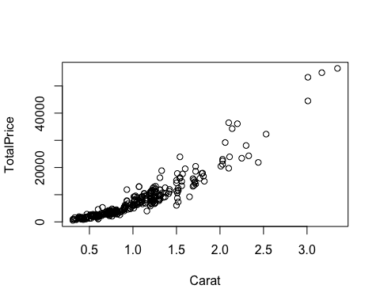

model = lm(TotalPrice~Carat+I(Carat^2))  
summary(model)

##   
## Call:  
## lm(formula = TotalPrice ~ Carat + I(Carat^2))  
##   
## Residuals:  
## Min 1Q Median 3Q Max   
## -10207.4 -711.6 -167.9 355.0 12147.3   
##   
## Coefficients:  
## Estimate Std. Error t value Pr(>|t|)   
## (Intercept) -522.7 466.3 -1.121 0.26307   
## Carat 2386.0 752.5 3.171 0.00166 **   
## I(Carat^2) 4498.2 263.0 17.101 < 2e-16 ***  
## ---  
## Signif. codes: 0 '***' 0.001 '**' 0.01 '*' 0.05 '.' 0.1 ' ' 1  
##   
## Residual standard error: 2127 on 348 degrees of freedom  
## Multiple R-squared: 0.9257, Adjusted R-squared: 0.9253   
## F-statistic: 2168 on 2 and 348 DF, p-value: < 2.2e-16

newx = data.frame(Carat=0.5)  
predict.lm(model, newx, interval='confidence')

## fit lwr upr  
## 1 1794.843 1424.296 2165.389

predict.lm(model, newx, interval='prediction')

## fit lwr upr  
## 1 1794.843 -2404.462 5994.147